

Year 12 Human Biology
Inquiry Assessment: Human Evolution

Name:
Teacher:

 | Marks Received | Marks Available | Percentage
Total |  | 35

Weighting: 5%

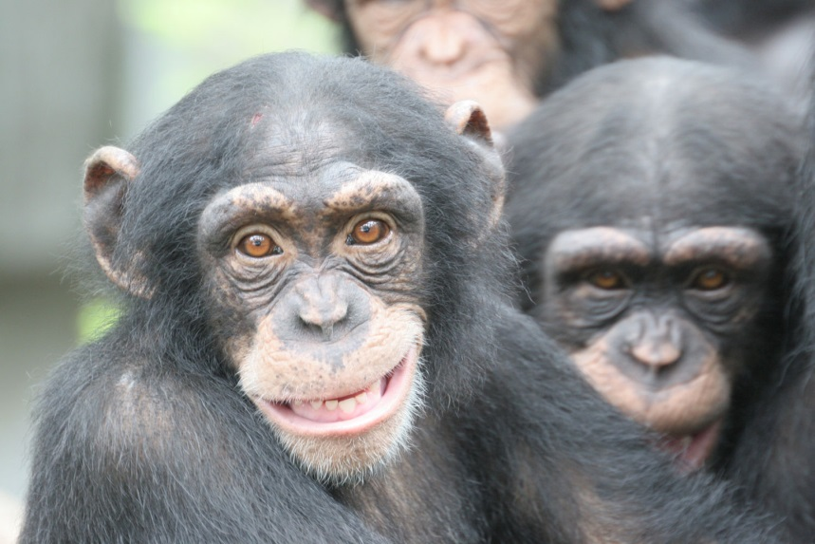

Hominin Species | Years Ago (MYA) | Average Brain Volume (cm³)
Australopithecus afarensis | 3.5 | 440
Australopithecus africanus | 2.5 | 450
Paranthropus robustus | 2.0 | 520
Homo habilis | 1.8 | 575
Homo erectus | 0.5 | 1100
Homo neanderthalensis | 0.05 | 1550
Homo floresiensis | 0.095 | 380
Homo sapiens | 0.08 | 1450
Table 1: Changes in Hominin brain volume over time

- Plot the data from Table 1 onto the graph paper below. (5 marks)

Graph 1:



Below there are three graphs. One compares the growth in brain size of humans and chimpanzees, one compares brain size and body height in the Hominin species and the last compares the relative size of brains in a variety of mammals. Use these graphs as well as the graph you have created above to answer the following questions.

Graph 2: Graph 3:

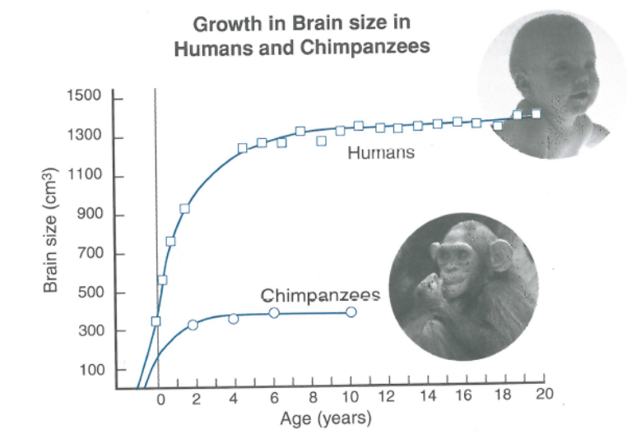

Graph 4:
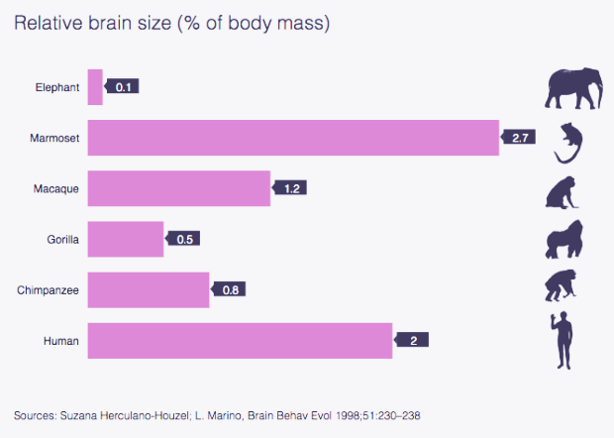

- Describe the evolutionary trend that Graph 1 illustrates. (2 marks)

- Comment on the significance of brain/body size growth curve in humans compared to chimpanzees. Explain a potential reason for this difference.
(4 marks)

4a. Explain the significance of the shapes in Graph 3 to compare H. sapiens and Australopithecines. (5 marks)

4b. Describe the overall patterns and trends present in Graph 3.
(3 marks)

5a. With respect to stature (body size) and brain size, comment on the position of Homo floresienis with respect to other hominins.
(2 marks)

5b. Comment on the significance of the tools discovered in the Flores find mentioned below graph 3.
(2 marks)

- Two parts of the brain; Broca’s area and Wernicke’s area have become highly developed in human compared to other Hominins. Describe a likely selection pressure that resulted in these changes and how it would provide a survival advantage. (3 marks)

- Name one variable which would influence the average brain volumes mentioned in Table 1. Explain your choice.
(2 marks)

- Predict the expected brain volume for a Hominin species that evolved 1 million years ago. (1 mark)

- Use data to explain whether relative size of the brain is indicative of intelligence. (3 marks)

- Construct a table in the space below from the data in Graph 4. (2 marks)

- Out of the species mentioned in the table, which would you expect to physically have the largest brain? (1 mark)

